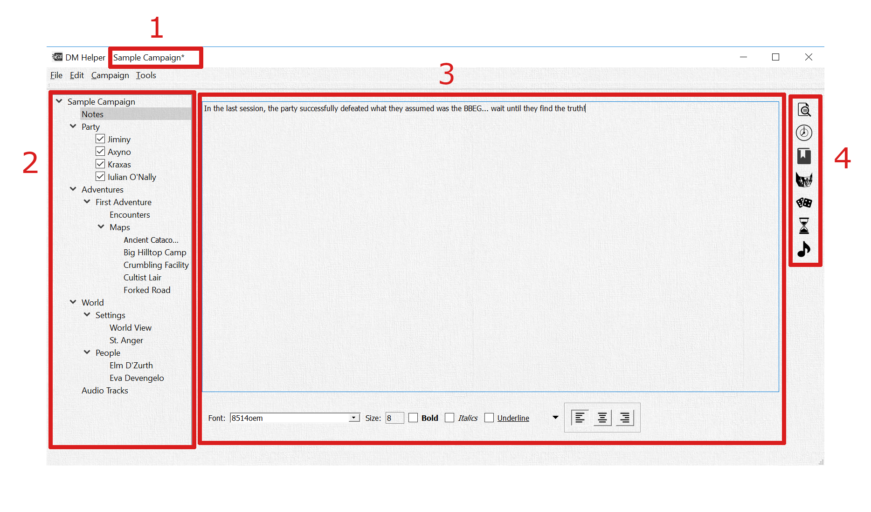

1. Campaign Title

TBD.

1. Campaign Tree

TBD.

1. Content Details

TBD.

1. Quick References

TBD